Mechanical Advantages of Pulley Systems
Introduction: Pulleys can change the direction of a force or reduce the force needed to move an object.
Question: Can a Pulley system even reduce the amount of work needed to lift an object?
Task: In this investigation, we will test three different pulley setups and determine the mechanical advantage and efficiency of each.
Materials: Stand, three pulleys, 1 single and 2 double. One large mass between 0.5 to 1 kg, string and scissors, force gauges (0-5N and 0-10N), metersticks.
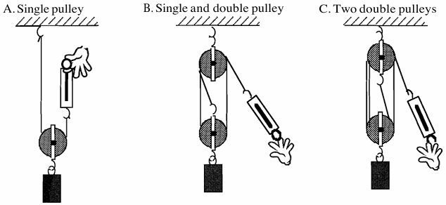
Procedure:

1.
